Online Retail (Customer Segmentation)

1. Problem Understanding
Business Problem: The retailer currently treats all customers the same way during marketing. This means that high-value customers and one-time customers receive identical treatment, which is an inefficient use of marketing resources. Sending the same blanket email campaign or discount code to every customer regardless of their value or purchasing habits means the business is likely overspending on customers who were never going to churn anyway, while under-investing in the customers who are either most valuable or most at risk of leaving.

Objective: Use unsupervised learning to segment customers into groups based on their spending behavior. This will enable the business to target each group with a more tailored marketing strategy, rather than relying on a single generic approach that is not optimized for anyone in particular. A segmentation-based approach also gives the marketing team a shared vocabulary when describing customers (e.g. “at-risk” vs “top-tier”), which are more actionable than raw transaction numbers alone.

Scope: Customers are described with the engineered RFM features: Recency, Frequency, and Monetary value (including Average order value) instead of just raw transaction data. RFM was chosen specifically because it condenses potentially thousands of individual transaction rows per customer into just a handful of behavioral summary statistics, which make clustering both computationally feasible and, more importantly, interpretable to a non-technical business audience.

2. Data Exploration and Preparation

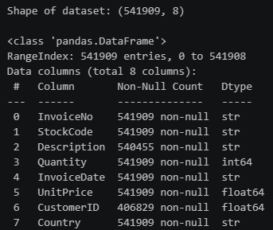
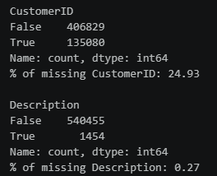
The raw dataset contains 541909 transaction rows across 8 columns. About 24.9% of the transactions have missing CustomerIDs. Since segmentation is customer-level, these rows cannot be assigned to any customer and were ultimately dropped. This is a fairly large chunk of data to lose, but there was no reasonable way to impute a CustomerID, since customer identity is not something that can be inferred from the other columns. Description only had 0.27% missing and was left alone since it is not used for clustering, so there was no need to clean it any further for this task.
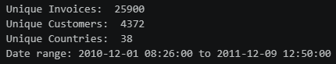
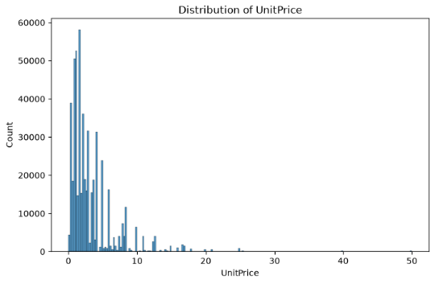
The dataset spans roughly over a year (Dec 2010 – Dec 2011) across 25900 unique invoices, 4372 unique customers, and 38 countries. This is enough customers to perform segmentation and a large enough date range for InvoiceDate to be used to calculate Recency once a reference date is set. A full year is also useful because it would capture any seasonal purchasing patterns (e.g. holiday shopping spikes) within a single snapshot, instead of only capturing part of a cycle.
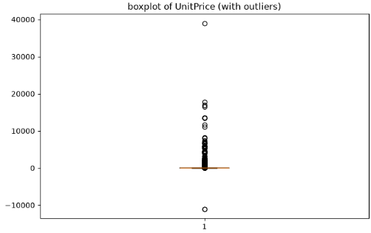
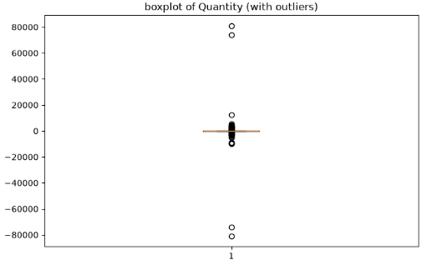
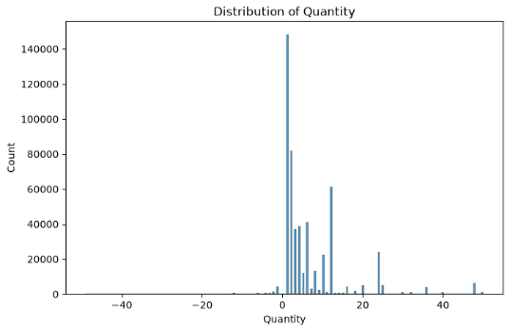
Both Quantity and UnitPrice are right skewed with several outliers. Boxplots confirmed this, including negative Quantity values marking returns or cancellations, which need to be removed as invalid transactions instead of treated as normal statistical outliers. This distinction mattered a lot for how the data was clean as a normal statistical outlier is still real, like a valid transaction that is just unusually large or small, whereas a cancellation or returned is not a genuine purchase at all, so it needed to be removed outright, rather than capped like a normal outlier would be.

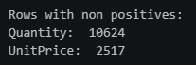
Other than those, there are 9288 InvoiceNo rows that starts with ‘C’, marking those rows as cancelled invoices with negative Quantity. Other than cancellations, a further 10624 rows had non-positive Quantity and 2517 rows had non-positive UnitPrice. They were removed as they would have distorted the Monetary and Average Value RFM features, since a negative or zero-value “purchase” would either understate or artificially deflate how much a customer has actually spent.

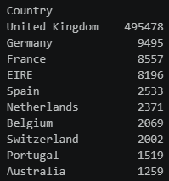
Transactions were heavily dominated by the UK, with Germany, France and Ireland (EIRE) trailing far behind. Seeing this imbalance, I decided to not use Country as a clustering feature, leaving RFM behavior being treated the same across customers regardless of country. Including a country as a feature with this level of imbalance would have likely caused the clustering algorithm to split customers largely along geographic lines rather than genuine purchasing behavior, since the UK alone would dominate any distance-based grouping simply by its large sample count, not because county is actually a meaningful behavioral signal.
I removed the rows with missing CustomerID, cancelled invoices, and non-positive Quantity/UnitPrices. That left me with 397884 valid rows, roughly 73% of the original dataset. While that is a substantial reduction, all the removed rows represented data that could not have meaningfully contributed to a genuine customer purchase, so retaining them would introduced noise rather than signal into the RFM calculations.

Identifying and handling outliers: I first implemented the IQR method with 1.5 as the multiplier to Quantity, UnitPrice, and the derived TotPrice (Quantity * UnitPrice) to find the upper and lower boundaries. The outliers for those 3 were capped to tighten their ranges before aggregation. Capping rather than removing was the more appropriate choice here, since these are still legitimate transactions (unlike the cancellations and non-positive rows removed earlier). The goal was just to stop a handful of extreme bulk orders from disproportionately skewing the RFM aggregation that follows, not to discard genuine customer purchases.

3. Feature Engineering for Clustering

Feature engineering: The now cleaned transactions were aggregated to customer level to build RFM features:
- Recency: days since each customer’s last purchase, relative to the maximum invoice date in the dataset
- Frequency: number of unique invoices per customer
- Monetary: total amount spent
- Average Value: Monetary / Frequency (engineered as fourth feature]

This produced 4338 customers with complete RFM profiles, which were then standardized with StandardScaler before being fed to the clustering models. Standardization was a necessary step here because Recency, Frequency, and Monetary are all measured on very different scales (days vs counts vs currency), and K-Means and Agglomerative Clustering both rely on Euclidean distance. Without scaling, Monetary alone (which can range into the thousands and more) would dominate the distance calculation and effectively drown out any signal from Recency or Frequency.

Average Value was also included as a fourth feature specifically because two customers can have identical Monetary and Frequency totals while differing completely in how they spend per visit *e.g. one large order vs many small ones), and that distinction is exactly the kind of nuance a plain RFM model would otherwise miss out on.

4. Build TWO Different Clustering Models

Two clustering approaches were used to build the models and were compared on the scaled RFM features:
- K-Means Clustering: the standard choice for customer segmentation, since it scales well to thousands of customers and produces easily interpretable centroids. Optimal k was chosen via the elbow method (SSE) and cross-checked with silhouette score.
- Agglomerative (Hierarchical) Clustering: it does not require the number of clusters to be fixed upfront. A dendrogram, with Ward linkage was used to visualise the natural groupings before deciding on a cluster count, again validated with silhouette score across a range of k.

By building two fundamentally different clustering approaches, if both a centroid-based method (K-Means) and a connectivity-based method (Agglomerative) arrived at a similar cluster count and similar customer groupings, that would give me much more confidence that the segments reflected are real structures in the data rather than just an artifact of one particular algorithm’s assumptions.

For K-Means, the elbow plot showed SSE dropping sharply around k = 4-5 before flattening out, and the silhouette score peaked at k=5 (0.477), so seeing that, I chose k=5 as the optimal k. Using both the elbow method and silhouette score together, rather than relying on just one, was important since the elbow method alone can be subjective to read (the "bend" isn't always obvious), while the silhouette score gives a more objective, quantifiable measure of cluster quality to confirm the visual read.
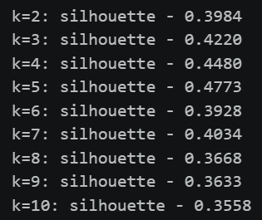
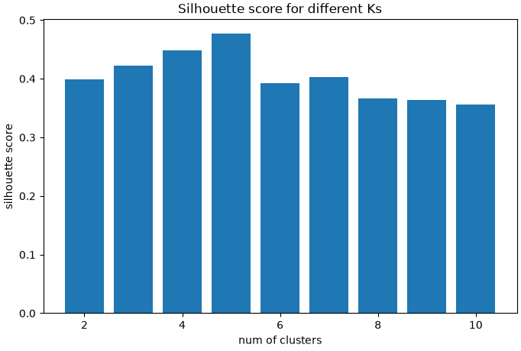
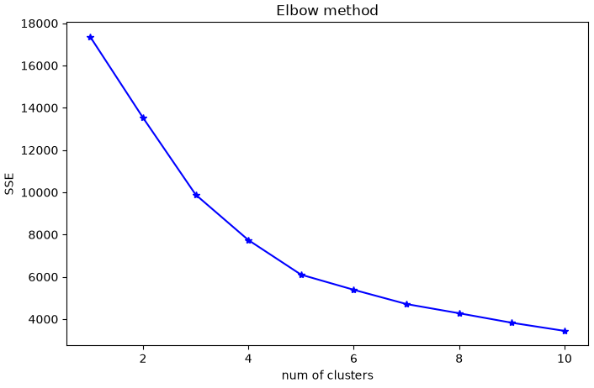

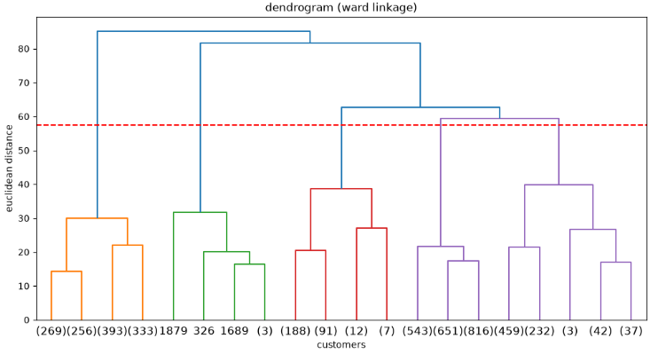
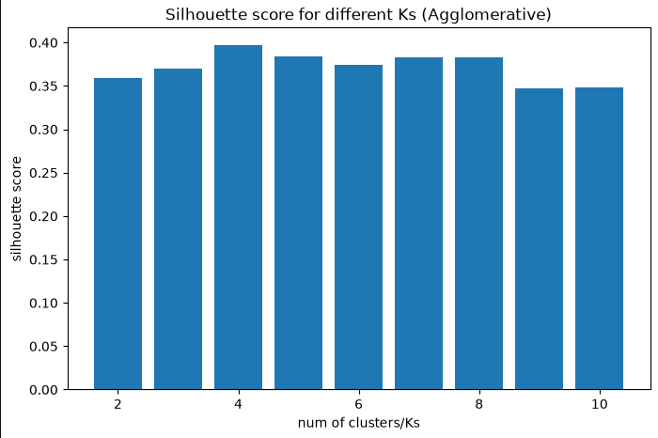
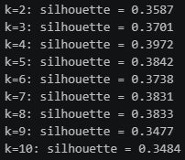
For Agglomerative Clustering, cutting the dendrogram at the midpoint of its longest unbroken vertical span also suggest 5 clusters. However, technically, the silhouette score peaked slightly higher at k=4 (0.397 vs 0.384 at k=5), k=5 was kept, allowing for an equal-footing comparison against the K-Means model. Choosing to prioritize comparability over the marginally higher score at k=4 was a conscious trade-off. The difference between 0.397 and 0.384 is small enough that it's unlikely to reflect a meaningfully better clustering, whereas keeping k consistent across both models make the final head-to-head comparison in section 4.5 much more meaningful.

5. Evaluate and Compare the Models

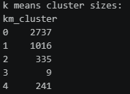
K-Means with k=5 produced cluster sizes of 2737 / 1016 / 335 / 9 / 241 customers, with a silhouette score of 0.477.
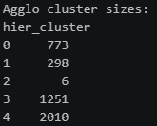


Agglomerative Clustering with k=5 produced cluster sizes of 773 / 298 / 6 / 1251 / 2010, with a silhouette score of 0.384.

K-Means produced the higher silhouette score, showing that its clusters are more compact and are better separated than those from Agglomerative Clustering. K-Means was therefore chosen as the preferred model for segment interpretation. It's also worth noting how differently the two models distributed customers across clusters despite using the same k:

- K-Means produced one dominant cluster of 2,737 customers alongside a very small cluster of 9
- Agglomerative Clustering spread customers more evenly across its larger clusters but also isolated an extremely small cluster of just 6.

This suggests both algorithms independently picked up on the existence of a very small, distinct customer group at the extreme end of the data, even though they disagreed on the sizing of everything else.

Cluster scatterplots (Recency vs Monetary and Frequency vs Monetary, both on log-scaled Monetary) and per-feature boxplots by cluster were used to visually sanity-check that the clusters correspond to genuinely different RFM behavior patterns rather than arbitrary splits. Log-scaling Monetary specifically was necessary because the raw values were heavily right-skewed by a small number of extremely high spenders, and without the log transform, those few points would have visually compressed all other clusters into a single indistinguishable region of the scatterplot.
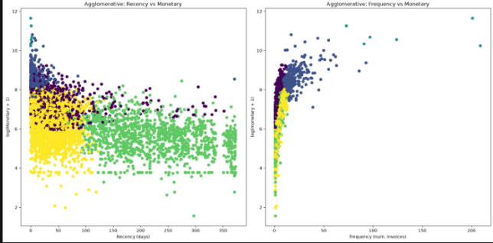
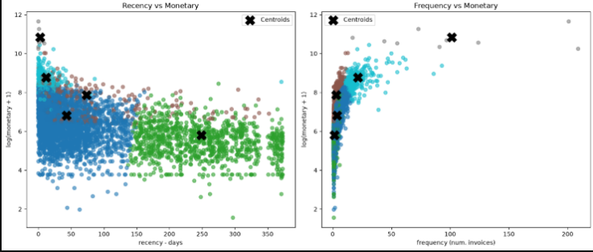

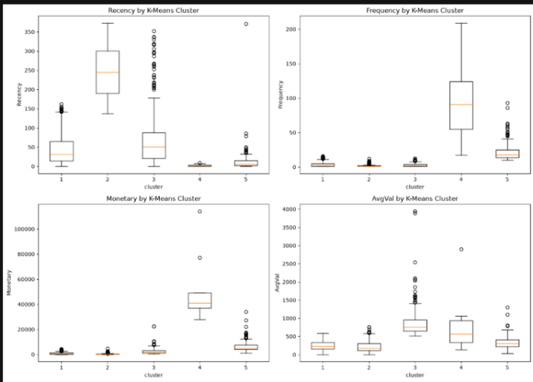
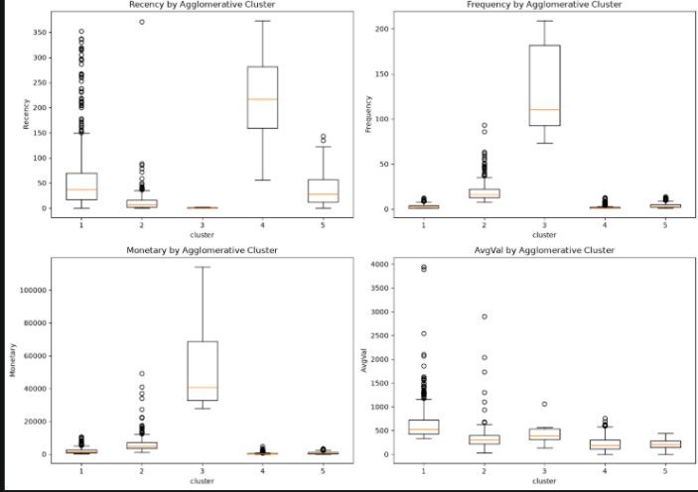

6. Segment Naming and Interpretation

The five K-Means clusters were profiled by their mean RFM values and given descriptive, non-technical names for easier interpretation. Naming the clusters in plain business language, rather than leaving them as numbered labels like "Cluster 0" through "Cluster 4," matters because the whole point of this task is for the marketing team to be able to act on these segments directly. A name like "at-risk-of-losing customers" immediately signals the marketing team the right kind of campaign to run, whereas "Cluster 4" would require someone to go back and re-derive what that cluster represents every time it comes up.

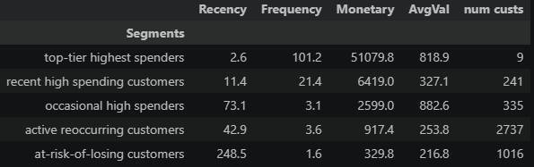

Top tier highest spenders: a very small but extremely valuable group.
Recommended action: retain at all costs. Through dedicated account management, exclusive offers, and early access to new products. Given how few customers fall into this group, the cost of these more resource-intensive retention efforts per customer is easily justified by how much revenue each individual customer in this segment represents.

Recent high spending customers: the strongest candidates to grow into the top-tier segment.
Recommended action: nurture with loyalty rewards and targeted upsell offers. This segment represents the clearest growth opportunity of the five, since these customers are already spending at a high level recently, the goal here is retention and gradual upgrade, not re-engagement.

Occasional high spenders: spend a lot per visit but visit infrequently.
Recommended action: occasional reminders to shop, since the potential order value is already high. This group already spends generously per visit. The priority is increasing how often they shop rather than trying to increase how much they spend each time.

Active reoccurring customers: the largest group and behavioral middle ground.
Recommended action: maintain frequent engagement through promotions, and cross-sell to increase basket size. Since this is by far the largest segment, even a small uplift in average spending per customer here would likely have the biggest absolute revenue impact of any single segment, simply due to its size.

At-risk-of-losing customers: have not purchased in a long time.
Recommended action: automated win-back email campaigns with discounts before they disengage completely. It would be a low-cost scalable intervention given the size of this group. Automation is particularly appropriate here because manually reaching out to a group this large would be far too resource-intensive relative to the expected return per customer, whereas a low-cost automated campaign can still recover a meaningful number of these customers on a scale.

7. Summary and Further Improvements

K-Means (k=5) was chosen over Agglomerative Clustering based on a clearly higher silhouette score of 0.477 vs 0.384, and its five clusters mapped cleanly onto business-interpretable segments ranging from a tiny “top-tier highest spenders” group worth protecting at all costs, to a large “at-risk-of-losing customers” group worth targeting with low-cost, automated win-back campaigns. This directly supports the original business objective of moving away from a one-size-fits-all marketing strategy. Beyond just picking the better-scoring algorithm, the choice of K-Means over Agglomerative Clustering also has a practical advantage worth mentioning. K-Means scales far more efficiently to large customer bases and can assign new customers to an existing segment in real time using the precomputed centroids, whereas Agglomerative Clustering would need to be re-run from scratch as new customer data comes in. This makes K-Means the more operationally realistic choice if this segmentation were to be refreshed on a recurring basis, like monthly, not just the more accurate one on this snapshot of data.

Both tasks share a common limitation: class/segment imbalance. In task 1, scores 3 and 9 have only 20 and 5 samples respectively, so the model has very little data to learn extreme scores from and predictions there should be trusted less. In task 2, the “top-tier highest spenders” clusters only have 9 customers. It’s informative for VIP treatment, but too small of a sample to validate cluster stability with confidence. A single customer joining or leaving a group could noticeably shift its centroid and profile. In both cases, the imbalance is not something that can be fixed by simply collecting more of the same kind of data passively. It reflects genuine rarity in the underlying population (very few wines score at the extremes, very few customers spend at that high level), so any fix must be deliberate rather than incidental.

Further improvements:
- Extending the RFM feature set with additional behavioural signals such as product category diversity, return rate, or average basket size, since 2 customers with identical Recency, Frequency, Monetary values could still differ meaningfully in what and how they buy, and richer features may reveal segments that RFM alone cannot distinguish.
- Re-running segmentation with extreme top-tier customers separated out beforehand, so the remaining clusters are not shaped by a handful of outlier accounts. This would let the model dedicate its full resolution to distinguishing patterns among the build of “normal” customers, rather than spending some of that resolution accounting for a few statistical extremes.
- Validating cluster stability across time periods. Which could look like splitting the year into two halves and checking whether the same segments emerge in both or tracking whether individual customers tend to stay in the same segment over time instead of jumping between them. Either would give more confidence that these segments reflect stable customer identities rather than a one-off snapshot of the current dataset.

